**Experiment No.7 Date:**

**Aim :** To write a program for full adder in VHDL.

**Apparatus :** PC, XILINXv5.2e software

**Theory:** A full adder adds binary numbers and accounts for values carried in as well as out. A one-bit full adder adds three one-bit numbers, often written as A, B, and Cin; A and B are the operands, and Cin is a bit carried in from the next less significant stage. The full-adder is usually a component in a cascade of adders, which add 8, 16, 32, etc. bit binary numbers. The circuit produces a two-bit output, output sum and carry typically represented by the signals S and Cout.

The full-adder is usually shown as a single unit. The sum output is usually on the bottom on the block, and the carry-out output is on the left, so the devices can be chained together, most significant bit leftmost:

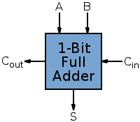

Fig 1: Full Adder

**Circuit Diagram:**

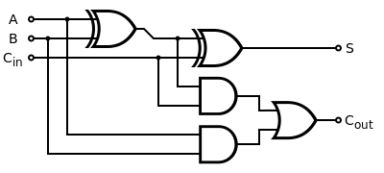

**Truth Table:**

|  |  |  |  |  |  |  |  |  |  |  |  |  |  |  |  |  |  |  |  |  |  |  |  |  |  |  |  |  |  |  |  |  |  |  |  |  |  |  |  |  |  |  |  |  |  |  |  |  |  |  |  |  |  |  |  |  |
| --- | --- | --- | --- | --- | --- | --- | --- | --- | --- | --- | --- | --- | --- | --- | --- | --- | --- | --- | --- | --- | --- | --- | --- | --- | --- | --- | --- | --- | --- | --- | --- | --- | --- | --- | --- | --- | --- | --- | --- | --- | --- | --- | --- | --- | --- | --- | --- | --- | --- | --- | --- | --- | --- | --- | --- | --- |
|  | |  |  |  |  |  |  |  | | --- | --- | --- | --- | --- | --- | --- | | **A** | **B** | **Cin** | **A+B+Cin** |  | **S** | **Cout** | | 0 | 0 | 0 | 0 | 0 | 0 | | 0 | 0 | 1 | 1 | 1 | 0 | | 0 | 1 | 0 | 1 | 1 | 0 | | 0 | 1 | 1 | 2 | 0 | 1 | | 1 | 0 | 0 | 1 | 1 | 0 | | 1 | 0 | 1 | 2 | 0 | 1 | | 1 | 1 | 0 | 2 | 0 | 1 | | 1 | 1 | 1 | 3 | 1 | 1 | |

**Procedure :** 1) Write program for the circuit in VHDL.

2) Check syntax and synthesize the program.

3)Simulate the program and verify the circuit by applying different combinations of inputs.

**Result :**

**Conclusion :**